International Etruscan Sigla Project Software Requirements Specification
Team Spannabe

I. Introduction
A. Purpose
The purpose of the Software Requirements Specification document is to clearly define the system for the International Etruscan Sigla Project (IESP). The indented audience of this document is the team working on the IESP and the development team.

B. Scope of the System Specified
The team working of the sigla project wants to create a system that stores information about the various artifacts that they collect during their studies. The researchers working on the project will be able to publish information about the artifacts they are studying. The general public will be able to view the artifacts through a web server.

- Definitions, Acronyms, and Abbreviations

Researcher | Person working on project who has permission to post material on the website
Contributor | Synonym for Researcher
Functional requirement | A service provided by the software system
Non-functional requirements | A constraint on the system or how the system is developed
Artifact | A physical object with one or more sigla on it
Sigla | Etruscan nonverbal writings
SRS | Software Requirements Specification document
IESP | International Etruscan Sigla Project
Entry | A posting of a single artifact on the web server that includes text, photos and drawings
Collection | Group of entries
EID | Entry Identification Number
CID | Collection Identification Number

D. References to Supporting Documents
There are none at this time.

E. Overview of rest of SRS
Section 2 of the SRS describes the product in more detail. Section 3 provides a complete list of the functional requirements of the intended system. Section 4 provides the non-functional requirements. Section 5 shows the class diagram, and Section 6 the use case diagram. The appendices appear next.

- General Description

- Product Perspective
The system is web-based, providing functionality to users through a web browser. It interfaces with a database that stores all of the relevant information regarding the authorized personnel, and the Etruscan artifacts. The system provides a secure environment for authorized personnel to submit information and manage data about Etruscan artifacts so that associations may be analyzed and better understood.

- Product Functions
The system allows public users to search entries by means of keywords, browsing trees, and by choosing from a list of similar entries. They may also view entries on the site and retrieve a citation of the corresponding artifact entry.
Authorized personnel have the ability to log into the system and manipulate the data. They’re split into two categories, contributors and system administrators.
A contributor has the ability to manipulate data by creating entries, creating collections of entries and modifying collections as well as unpublished entries. They also have the ability to add additional information to each entry. A contributor may choose to make data official and publish an entry to be displayed. Once published, they may no longer modify an entry. Each contributor also has the same abilities as public users.
A system administrator is allowed to manage contributor accounts as well as modify published entries. Because a contributor must be verified before their account is activated, this is an important task to the system. Also, they are the only one who may modify any data once it’s been published so that the system remains stable and accurate. System Administrators have the additional permissions of both contributors as well as public users.

- User Characteristics
Interaction with the system is carried out by the three groups of public users, contributors and system administrators. A public user is anyone who is accessing the system without the need for any special permissions. They are limited in functionality, but require nothing more than the knowledge of how to use a web browser.
A contributor is someone who has been authorized to log into the site and modify data. They must be familiar with the format of the system as well as the relevant data for an artifact entry. This may require minimal training in order to familiarize oneself with the system. A contributor has the ability to organize entries in the form of a collection to provide more ease of use.
A system administrator is someone who has authorization to log into the site, as well as modify publish and unpublished entries. It is the responsibility of a system administrator to verify and manage contributor accounts. They must be very familiar with the system and understand the requirements of entries and contributors. They have the highest permissions in the system and may modify data that has been published and is important to keep consistent.

- General Constraints
The system provides web access for all users. The user interface should be intuitive enough so that there is no training required to search and view entries or generate citations. Contributors and system administrators must also be able to easily understand the system and how to create and modify data appropriately. All data of authorized personnel as well as artifact information will be stored securely. Persistent information on all artifacts and authorized personnel will be maintained.

- Assumptions and Dependencies
There are no assumptions or dependencies at this time.

3. Functional Requirements
3.1 The system shall store text data.
3.2 The system shall store images and drawings.
3.3 The system shall store epigraphs.
3.4 The system shall allow researchers to create entries.
3.5 The system shall allow researchers to modify their own non published entries.
3.6 The system shall number entries with unique key.
3.7 The system shall make researchers log in to the system for authorized access.
3.8 The system shall allow researchers to create comments.
3.9 The system shall allow the public to view the collection.
3.10 The system shall allow researchers to mark entries as: private(incomplete), protected(under peer review), public(published).
3.11 The system shall enable a researcher to provide protected access to ones data for other researchers.
3.12 The system shall allow researchers to tag an entry with a keyword.
3.13 The system shall generate citations for entries.
3.14 The system shall allow only the system administrator to modify entries after publishing.
3.15 The system shall allow researchers to create collects of entries.
3.15.1 The system shall allow researchers to modify their collections.
3.16 The system shall allow the administrator to modify contributors accounts.
3.17 The system shall provide graphical annotation for artifact images.
3.18 The system shall provide detail data for the entries.

4. Non-Functional Requirements
4.1 The system shall allow for secure log in for researchers and system administrators.
4.2 The system shall provide an intuitive user interface.
4.2.1 The system shall provide an easy to use data entry form for researchers.
4.3 The system shall provide persistent storage of all data.
4.4 The system shall provide support for multiple languages.
4.5 The site shall have a consistent format.
4.6 The site shall be coded in a uniform software language.
4.7 The site shall be usable in multiple browsers.

5. Class Diagram
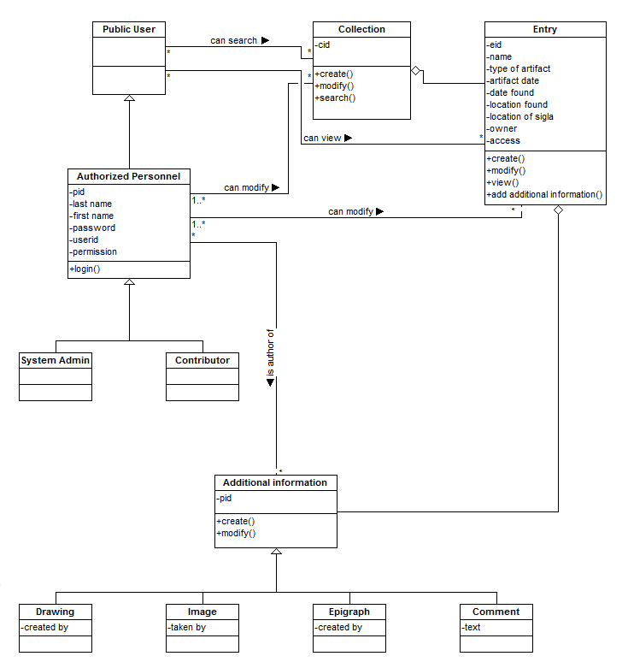

6. Use Case Diagram
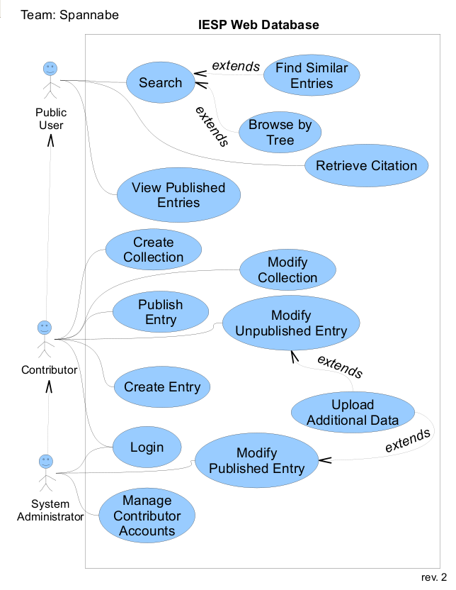
Appendix A. Class and Actor Descriptions

Name | Additional Information
Description | a resource associated with an Entry

Attributes
Name of Attribute | Data Type | Description
rid | integer | unique resource number

Methods
Method Signature | Description
create() | create a new info object
modify() | modify an existing info object

Relationships
Class Name | Type of Relationship | Comments
Drawing | Parent
Image | Parent
Epigraph | Parent
Comment | Parent

Name | Authorized Personnel
Description | actor who has greater access through logging in

Attributes
Name of Attribute | Data Type | Description
pid | integer | unique number for the user
last_name | string | last name of the user
first_name | string | first name of the user
userid | string | user id of the user
password | string | user-defined password
permission | enum | what level of permission the user has

Methods
Method Signature | Description
create() | create a new user account
login() | logs the user into the system

Relationships
Class Name | Type of Relationship | Comments
System Admin | Parent | a System Administrator is a type of Authorized Personnel
Contributor | Parent | a Contributor is a type of Authorized Personnel
Public User | Child | Authorized Personnel are like Public Users with greater privileges and a designated login.

Name | Collection
Description | object representing a container of Entry objects

Attributes
Name of Attribute | Data Type | Description
cid | integer | unique number identifying the collection

Methods
Method Signature | Description
create() | create a new collection
modify() | modify the contents of an existing collection
search() | search for an entry in the collection
add_entry() | add an entry to the collection

Relationships
Class Name | Type of Relationship | Comments
Entry | Child | a collection contains entries

Name | Comment
Description | a resource associated with an Entry

Attributes
Name of Attribute | Data Type | Description
text | string | the text of the comment
author | string | the author of the comment

Methods
Method Signature | Description
none

Relationships
Class Name | Type of Relationship | Comments
Additional Information | Child | an Comment is a type of Additional Information

Name | Drawing
Description | a resource associated with an Entry

Attributes
Name of Attribute | Data Type | Description
image | image | image data
created_by | string | illustrator of this image

Methods
Method Signature | Description
none

Relationships
Class Name | Type of Relationship | Comments
Additional Information | Child | a Drawing is a type of Additional Information

Name | Entry
Description | object representing a sigla entry in the database

Attributes
Name of Attribute | Data Type | Description
eid | integer | unique number for this artifact
name | string | name of the entry
owner | Contributor | researcher who created this entry
date_found | date | date of the find
date_original | date | date of the artifact
location_found | string | where the artifact was found
access_mode | Enum | for this entry (public, private, protected)
artifact_type | string | the type of artifact for this entry
sigla_location | string | location of the sigla on the artifact

Methods
Method Signature | Description
create() | create a new entry
modify() | modify existing entry data (allowed based on permissions)
view() | return all of the data for this object for display
add_info() | associate additional information, such as images

Relationships
Class Name | Type of Relationship | Comments
Contributor | Association | a contributor owns an entry
Additional Information | Child | Other info tied to the entry.
Collection | Parent | An entry can be part of a collection.

Name | Epigraph
Description | a resource associated with an Entry

Attributes
Name of Attribute | Data Type | Description
vector | blob | path information of the epigraph
created_by | string | creator of this epigraph

Methods
Method Signature | Description
none

Relationships
Class Name | Type of Relationship | Comments
Additional Information | Child | an Epigraph is a type of Additional Information

Name | Image
Description | a resource associated with an Entry

Attributes
Name of Attribute | Data Type | Description
image | data | image data
taken_by | string | photographer of this image
date_taken | date | date this image was taken

Methods
Method Signature | Description
none

Relationships
Class Name | Type of Relationship | Comments
Additional Information | Child | an Image is a type of Additional Information

Use Case Descriptions

Name | Login
ID | 1
Requirement Number | 3.7
Description | A user logs into the system with their username and password
Primary Actor | Contributor
Secondary Actor(s) | System Administrator
Pre-condition | User has an account
Post-condition | User will be logged into the system as either a contributor or a system administrator.  User will now have the appropriate options to modify data.
Trigger | User chooses “Login” option

Normal Scenario
1. | User inputs username into username text field.
2. | User inputs password into password text field.
3. | User chooses “Login” button.
4. | System validates login information.
5. | System displays “Successful login” message.

Extensions
4.1 | Login validation fails due to incorrect or missing information  4.1.a System displays a failed login message.  4.1.b System clears the login and password fields.

Name | Search
ID | 2
Requirement Number | 3.10
Description | The user searches the system based on keywords
Primary Actor | Public User
Secondary Actor(s) | Contributor, System Administrator
Pre-condition | User has accessed site and typed keyword(s) into the search field.
Post-condition | System will display artifact pages relevant to keywords
Trigger | User chooses the “Search” option

Normal Scenario
1. | User enters keywords into search text field.
2. | User optionally changes the search criteria (default is all types) which includes researcher, sigla, keywords, year found, etc.
3. | User clicks “search button”.
4. | System tokenizes all the words entered into search text field.
5. | System checks the database for any artifacts with criteria matching keyword.
6. | System adds artifacts to a list.
7. | Repeat steps 5-6 as necessary.
8. | System displays a list of possible artifacts ranging from most relevant to least relevant (relevant meaning most matching criteria).

Extensions
4.1 | Search field is blank  4.1.a System displays “No search information” message.
6.1 | Nothing matching current keyword exists  6.1.a Move to the next keyword without adding anything

Name | Retrieve Citation
ID | 3
Requirement Number | 3.14
Description | The system provides a citation of the artifact’s site.
Primary Actor | Public Citation
Secondary Actor(s) | Contributor, System Administrator
Pre-condition | User is viewing artifact information
Post-condition | System displays citation for artifact webpage being viewed.
Trigger | User chooses “Generate Citation” option.

Normal Scenario
1. | System gathers artifact information.
2. | System creates a formatted citation for reference use according to APA standards.
3. | System creates new window.
4. | System displays citation in new window.

Extensions
3.1 | System cannot create new window  3.1.a Display window creation error message.

Name | Create Entry
ID | 5
Requirement Number | 3.4
Description | Defines how the contributor and system administrator create new entries to the system
Primary Actor | Contributor or System Administrator
Secondary Actor(s)
Pre-condition | User must have contributor or system administrative permissions
Post-condition | A newly created entry exists in the system, user logged into the system
Trigger | User selects to create a new entry

Normal Scenario
1. | User selects option to create new entry
2. | System provides a form with fields and text boxes to add new data
3. | User adds all data corresponding to the new entry
4. | User saves new entry
5. | System provides a successful message that new data has been updated
6. | User logs out of the system

Extensions
5.1 | Formatting of form fields is wrong  5.1.a – Provide the user with an error message and allow for changes to be made to the form

Name | Upload Additional Data
ID | 4
Requirement Number | 3.5
Description | Defines how the contributor and system administrator upload additional data to already publish entries
Primary Actor | Contributor or System Administrator
Secondary Actor(s)
Pre-condition | A published entry already exist, user must have contributor or system administrative permissions, user logged into the system
Post-condition | Entry has been updated
Trigger | User selects to add new data to existing entry

Normal Scenario
1. | User selects to search for an entry
2. | System provides a pop up window to find a particular entry
3. | User selects an entry
4. | User selects option to upload additional data to an entry
5. | System provides a form with fields and text boxes to add new data
6. | User adds all new data corresponding to the entry
7. | User saves additional data to entry
8. | System provides a successful message that the new data has been updated
9. | User signs out of system

Extensions
3.1 | Chosen entry does not exist:  3.1.a – User creates a new entry into system
8.1 | Formatting of form fields is wrong  8.1.a – Provide the user with an error message and allow for changes to be made to the form

Name | Publish Entry
ID | 6
Requirement Number | 3.10
Description | Defines how the contributor and system administrator publish newly created entries to the system
Primary Actor | Contributor or System Administrator
Secondary Actor(s)
Pre-condition | User must have contributor or system administrative permissions, a created entry must exist, user logged into the system
Post-condition | A newly published entry in the system viewable to all users
Trigger | User selects to publish a completed entry

Normal Scenario
1. | User selects to search for an entry
2. | System provides a pop up window to find a particular entry
3. | User selects an entry
4. | User selects option to publish completed entry
5. | System provides a form with fields and text boxes to revises entry data
6. | User changes any fields if necessary
7. | User chooses to publish entry
8. | System provides a successful message that new data has been updated
9. | User logs out of the system

Extensions
1.1 | Entry does not exist:  1.1.a – User creates new entry, go to step 4
8.1 | Formatting of form fields is wrong  8.1.a – Provide the user with an error message and allow for changes to be made to the form

Name | Modify Collection
ID | 7
Requirement Number | 03/15/01
Description | Defines how the contributor and system administrator modify existing collections of entries
Primary Actor | Contributor or System Administrator
Secondary Actor(s)
Pre-condition | User must have contributor or system administrative permissions, a collection must already exist, user logged into the system
Post-condition | An updated existing collection with specified changes made to it
Trigger | User selects to modify specific collection

Normal Scenario
1. | User selects to search for a collection
2. | System provides a pop up window to find a particular collection
3. | User selects a collection
4. | User selects option to modify collection
5. | System provides a form with fields and text boxes to revise collection data
6. | User modifies collection
7. | User saves modifications to collection
8. | System provides a successful message that new data has been updated
9. | User logs out of system

Extensions
1.1 | Collection does not exist:  1.1.a – User makes collection of specified entries, go to step 4
8.1 | Formatting of form fields is wrong  8.1.a – Provide the user with an error message and allow for changes to be made to the form

Name | Modify Unpublished Entry
ID | 8
Requirement Number | 3.5
Description | This use case defines how a contributor can modify their unpublished entries.
Primary Actor | Contributor
Secondary Actor(s) | System Administrator
Pre-condition | An unpublished entry exists.
Post-condition | An unpublished entry is modified.
Trigger | Contributor selects the Modify Unpublished Entry option in the system.

Normal Scenario
1. | Contributor logs in to the system.
2. | Contributor selects which of his entries to modify.
3. | Contributor changes text, photos or drawings for the entry.
4. | Contributor saves his changes.
5. | Changes are written to the database.
6. | Contributor logs out of the system.

Extensions
6.1 | Contributor has not saved changes:  6.1a System prompts user to see if he wants to save changes.

Name | Modify Published Entry
ID | 9
Requirement Number | 3.15
Description | This use case defines how a published entry may be modified.
Primary Actor | System Administrator
Secondary Actor(s)
Pre-condition | A Published entry with an error exists.
Post-condition | A Published entry is modified.
Trigger | System Administrator selects the Modify Published Entry option in the system.

Normal Scenario
1. | System Administrator logs in to the system.
2. | System Administrator finds the entry with an error.
3. | System Administrator fixes the error.
4. | System Administrator saves the changes.
5. | Changes are written to the database.
6. | System Administrator logs out of the system.

Extensions
4.1 | The System reminds the user that the entry has been published  4.1a System prompts user to make sure he wants to save changes.

Name | Manage Contributor Accounts
ID | 10
Requirement Number | 3.16
Description | This use case defines how Contributor accounts are created.
Primary Actor | System Administrator
Secondary Actor(s)
Pre-condition | A System Administrator and another person exist.
Post-condition | A Contributor account is created or the request is denied.
Trigger | A person requests creation of a Contributor account.

Normal Scenario
1. | System Administrator logs in to the system.
2. | System Administrator looks up the account request.
3. | System Administrator evaluates the requester.
4. | System Administrator decides if the request will be granted.
5. | If the request is granted the account is created, otherwise nothing happens.
6. | System Administrator notifies the requestor of the decision.
7. | System Administrator logs out of the system.

Name | Browse by Tree
ID | 11
Requirement Number | 3.9
Description | This use case defines how the public can view the entries.
Primary Actor | Public User
Secondary Actor(s)
Pre-condition | An Entry exists.
Post-condition | One or more Entries are viewed.
Trigger | A public user loads the website.

Normal Scenario
1. | User clicks on a link to go to another page.
2. | Step 1 is repeated until the User finds an entry they wish to view.
3. | Steps 1 and 2 are repeated until the User is done looking.
4. | The User leaves the website.

Extensions
1.1 | User clicks on a link:  1.1a User is brought to another page or the menu he is clicking on changes to show more options.

Attribute Descriptions

Name | rid
Class Name | AdditionalInformation
Alternate Name(s) | resource identifier
Type | integer
Length | any
Output Format | numeric
Default Value | -1
Acceptable Values | 0 through MAX_INT
Source (where value comes from) | generated automatically
Derivation Formula | 1 + rid of last generated value
Description | uniquely tags image and other data in the system
Comments | none

Name | firstname
Class Name | Authorized Personnel
Alternate Name(s) | none
Type | string
Length | any
Output Format | string
Default Value | NULL
Acceptable Values | any
Source (where value comes from) | the user, during account creation
Derivation Formula | none
Description | first name of the user
Comments | none

Name | lastname
Class Name | Authorized Personnel
Alternate Name(s) | none
Type | string
Length | any
Output Format | string
Default Value | NULL
Acceptable Values | any
Source (where value comes from) | the user, during account creation
Derivation Formula | none
Description | last name of the user
Comments | none

Name | password
Class Name | Authorized Personnel
Alternate Name(s) | none
Type | string
Length | 6-10 characters
Output Format | string
Default Value | none
Acceptable Values | any
Source (where value comes from) | the user, during account creation
Derivation Formula | none
Description | the user's password
Comments | must meet minimum security requirements for password complexity

Name | permission
Class Name | Authorized Personnel
Alternate Name(s) | none
Type | enum
Length | n/a
Output Format | n/a
Default Value | PUBLIC
Acceptable Values | any
Source (where value comes from) | assigned by a system administrator to another account, based on their access permissions
Derivation Formula | none
Description | enum showing the access level of a certain user
Comments | not modifiable by anyone other than a system administrator

Name | pid
Class Name | Authorized Personnel
Alternate Name(s) | personnel id
Type | integer
Length | any
Output Format | numeric
Default Value | -1
Acceptable Values | 0 through MAX_INT
Source (where value comes from) | generated automatically
Derivation Formula | 1 + rid of last generated value
Description | uniquely id of a user
Comments | none

Name | userid
Class Name | Authorized Personnel
Alternate Name(s) | none
Type | string
Length | 6-12 characters
Output Format | string
Default Value | lastname
Acceptable Values | any
Source (where value comes from) | the user, during account creation, contingent upon availability of the name
Derivation Formula | none
Description | the user's unique account username
Comments | none

Name | cid
Class Name | Collection
Alternate Name(s) | none
Type | integer
Length | any
Output Format | numeric
Default Value | -1
Acceptable Values | 0 to MAX_INT
Source (where value comes from) | automatically generated when the collection is created
Derivation Formula | 1 + the last cid generated
Description | the unique identifier of a collection
Comments | none

Name | author
Class Name | Comment
Alternate Name(s) | none
Type | string
Length | any
Output Format | string
Default Value | NULL
Acceptable Values | a username
Source (where value comes from) | the user who initiates comment creation
Derivation Formula | none
Description | the author of the comment
Comments | none

Name | text
Class Name | Comment
Alternate Name(s) | none
Type | string
Length | any
Output Format | string
Default Value | NULL
Acceptable Values | any
Source (where value comes from) | the user who initiates comment creation
Derivation Formula | none
Description | the main text of a comment
Comments | none

Name | created_by
Class Name | Drawing
Alternate Name(s) | none
Type | string
Length | any
Output Format | string
Default Value | NULL
Acceptable Values | any
Source (where value comes from) | the user upon creation of drawing resource
Derivation Formula | none
Description | the name of the individual who drew this drawing
Comments | none

Name | image
Class Name | Drawing
Alternate Name(s) | none
Type | Image
Length | n/a
Output Format | Image
Default Value | NULL
Acceptable Values | any Image data
Source (where value comes from) | the user upon creation of drawing resource
Derivation Formula | none
Description | the actual data of the drawing resource
Comments | none

Name | date_found
Class Name | Entry
Alternate Name(s) | none
Type | date
Length | any
Output Format | date
Default Value | NULL
Acceptable Values | any
Source (where value comes from) | the user during creation of the entry
Derivation Formula | none
Description | the date the artifact was found
Comments | none

Name | date_original
Class Name | Entry
Alternate Name(s) | none
Type | date range
Length | any
Output Format | range of dates
Default Value | NULL
Acceptable Values | any
Source (where value comes from) | the user during creation of the entry
Derivation Formula | none
Description | the approximate date of the artifact, as a range
Comments | the range is really two dates comprising the possible range of dates for the artifact

Name | eid
Class Name | Entry
Alternate Name(s) | none
Type | integer
Length | any
Output Format | numeric
Default Value | -1
Acceptable Values | 0 to MAX_INT
Source (where value comes from) | automatically generated upon creation of new entry
Derivation Formula | 1 + the last eid generated
Description | unique identifier of an entry in the system
Comments | none

Name | location_found
Class Name | Entry
Alternate Name(s) | none
Type | string
Length | any
Output Format | string
Default Value | NULL
Acceptable Values | any
Source (where value comes from) | the user during creation of the entry
Derivation Formula | none
Description | the location where the artifact was found
Comments | could be a name, or even GPS values

Name | access_mode
Class Name | Entry
Alternate Name(s) | none
Type | enum
Length | n/a
Output Format | n/a
Default Value | PRIVATE
Acceptable Values | any valid enumeration
Source (where value comes from) | the user during creation or modification of the entry
Derivation Formula | none
Description | the user's designated access mode for the entry, determining who can see it
Comments | primarily of the form private, protected, and public

Name | name
Class Name | Entry
Alternate Name(s) | none
Type | string
Length | any
Output Format | string
Default Value | eid
Acceptable Values | any
Source (where value comes from) | the user during creation of the entry
Derivation Formula | none
Description | the title assigned to the entry by the user, not necessarily unique
Comments | none

Name | owner
Class Name | Entry
Alternate Name(s) | none
Type | Contributor
Length | n/a
Output Format | n/a
Default Value | NULL
Acceptable Values | any valid contributor
Source (where value comes from) | automatically assigned based on the user who is creating the entry
Derivation Formula | none
Description | the contributor who ''owns'' the entry
Comments | none

Name | sigla_location
Class Name | Entry
Alternate Name(s) | none
Type | string
Length | any
Output Format | string
Default Value | NULL
Acceptable Values | any
Source (where value comes from) | the user during creation of the entry
Derivation Formula | none
Description | the described location of the sigla on the artifact
Comments | none

Name | artifact_type
Class Name | Entry
Alternate Name(s) | none
Type | string
Length | any
Output Format | string
Default Value | NULL
Acceptable Values | any
Source (where value comes from) | the user during creation of the entry
Derivation Formula | none
Description | the type of artifact
Comments | none

Name | created_by
Class Name | Epigraph
Alternate Name(s) | none
Type | string
Length | any
Output Format | string
Default Value | user creating the epigraph object
Acceptable Values | any
Source (where value comes from) | the user upon creation of the epigraph resource
Derivation Formula | none
Description | the individual who created the epigraph
Comments | none

Name | vector
Class Name | Epigraph
Alternate Name(s) | path
Type | blob
Length | n/a
Output Format | any
Default Value | NULL
Acceptable Values | any valid data representing the vector path of the epigraph
Source (where value comes from) | the user upon creation of the epigraph resource
Derivation Formula | none
Description | the actual vector data for the epigraph, usually machine generated file
Comments | all vectors should be stored to a similar file-type

Name | date_taken
Class Name | Image
Alternate Name(s) | none
Type | date
Length | any
Output Format | date
Default Value | creation date
Acceptable Values | any
Source (where value comes from) | the user upon creation of image resource
Derivation Formula | none
Description | the date the photo was taken
Comments | none

Name | image
Class Name | Image
Alternate Name(s) | none
Type | Image
Length | n/a
Output Format | Image
Default Value | NULL
Acceptable Values | any Image data
Source (where value comes from) | the user upon creation of image resource
Derivation Formula | none
Description | the actual data of the image resource
Comments | none

Name | taken_by
Class Name | Image
Alternate Name(s) | none
Type | string
Length | any
Output Format | string
Default Value | NULL
Acceptable Values | any
Source (where value comes from) | the user upon creation of image resource
Derivation Formula | none
Description | the name of the individual who took this photo
Comments | none

Appendix B: Raw Use Case Analysis

Use Case Name
Use Case Name | Number of Transactions | Use Case Type | Use Case Points
Search | 5 | Average | 10
Find Similar Entries | 4 | Average | 10
Browse by Tree | 4 | Average | 10
Retrieve Citation | 3 | Simple | 5
View Published Entries | 3 | Simple | 5
Create Collection | 2 | Simple | 5
Modify Collection | 2 | Simple | 5
Publish Entry | 2 | Simple | 5
Modify Unpublished Entry | 4 | Average | 10
Create Entry | 2 | Simple | 5
Login | 2 | Simple | 5
Upload Additional Data | 4 | Average | 10
Modify Published Entry | 3 | Simple | 5
Manage Contributor Accounts | 1 | Simple | 5
 |  | Total: | 95

Actor Points
Actor Name | Actor Type | Actor Points
Public User | Complex | 3
Contributor | Complex | 3
System Administrator | Complex | 3
 | Total | 9

Appendix C: Screens and Navigation Matrix

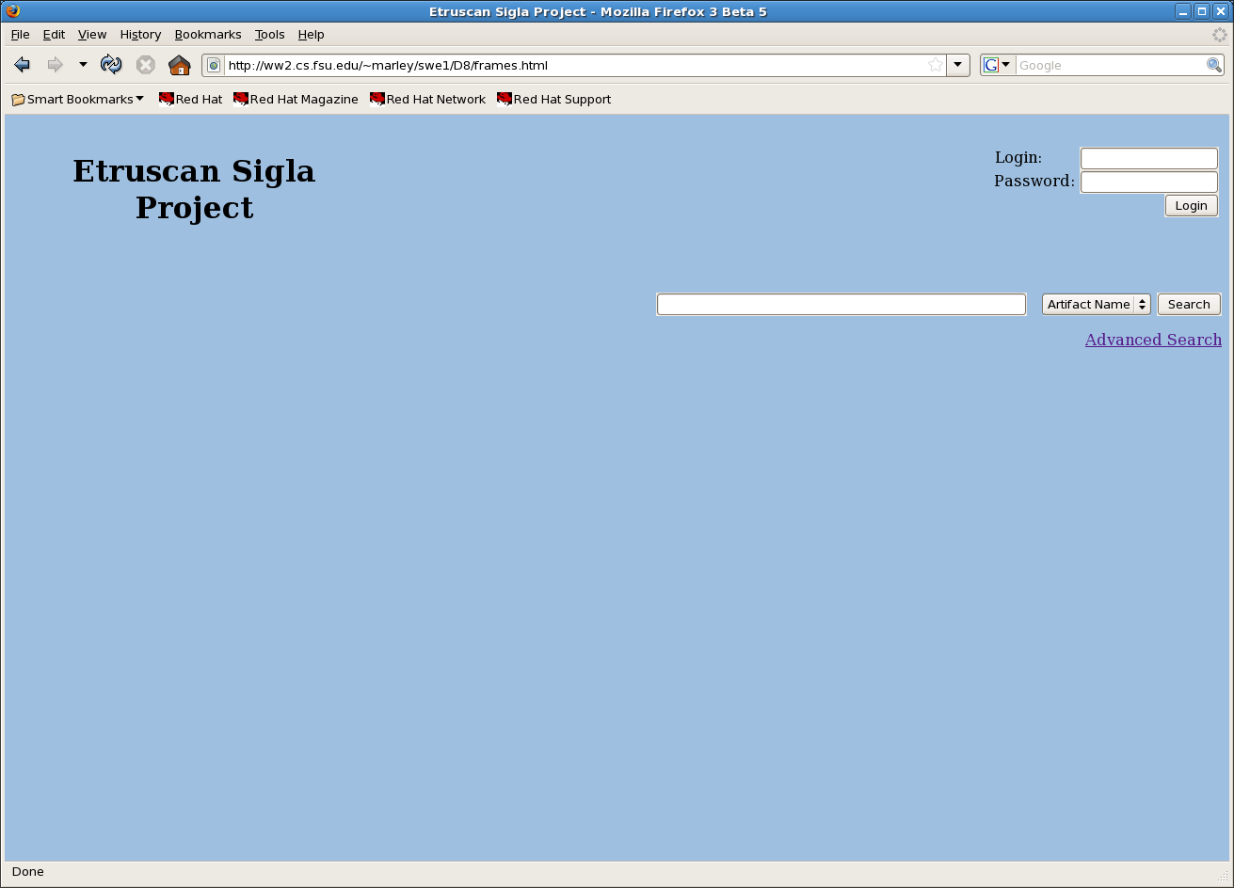

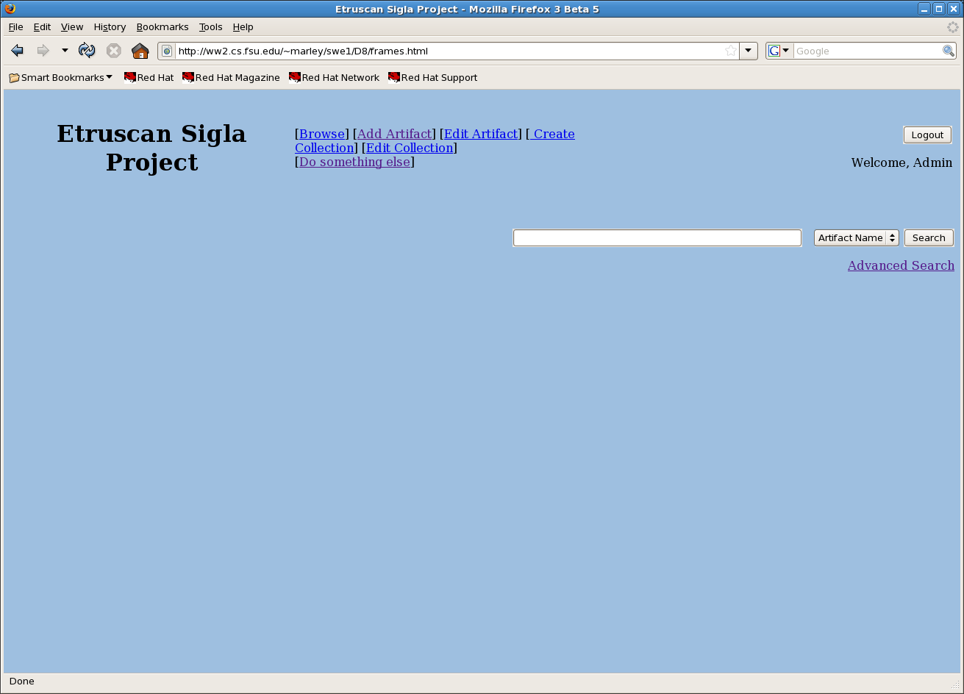

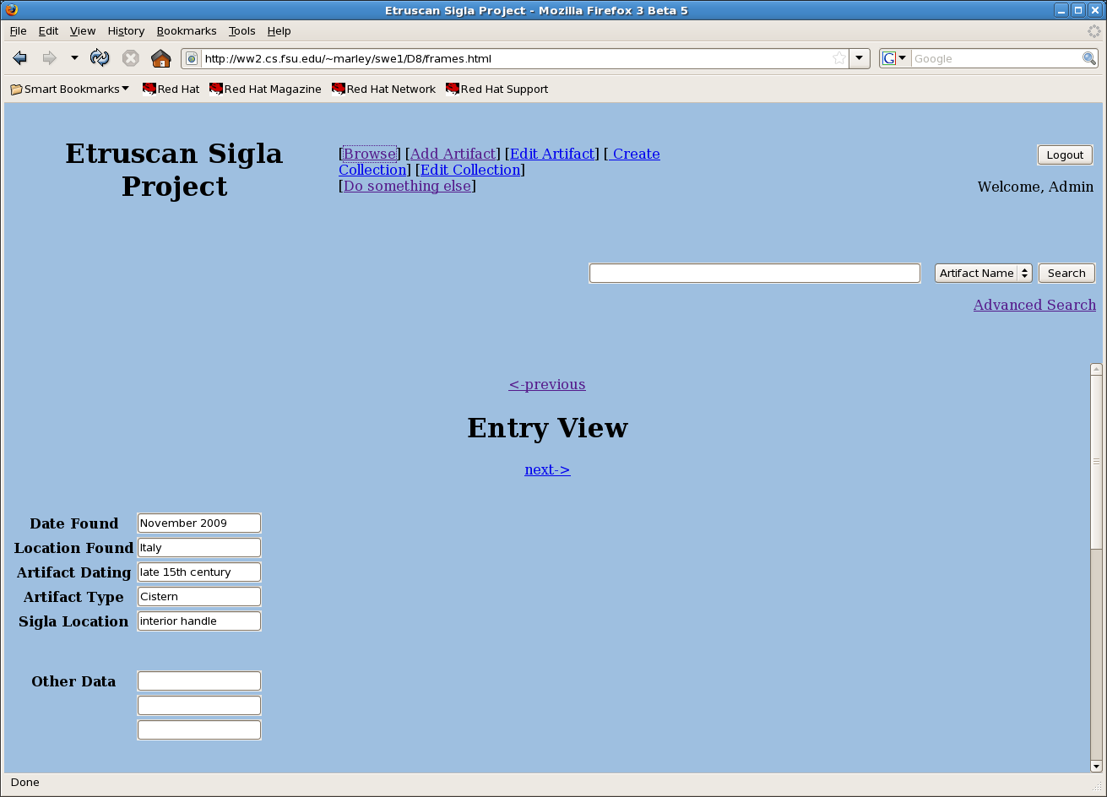

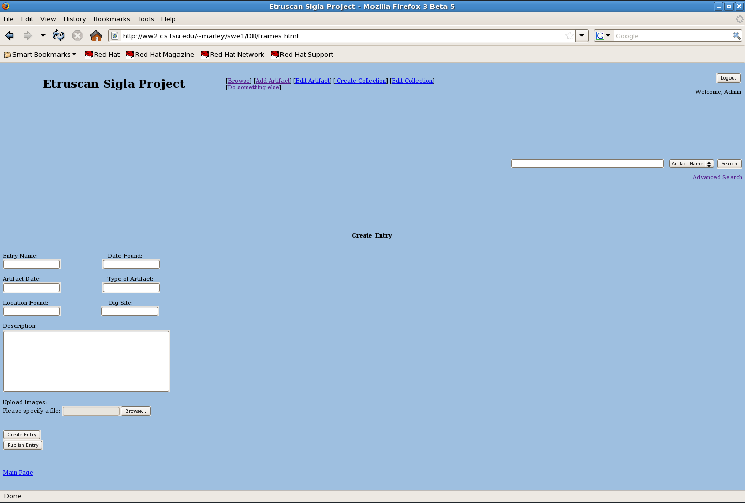

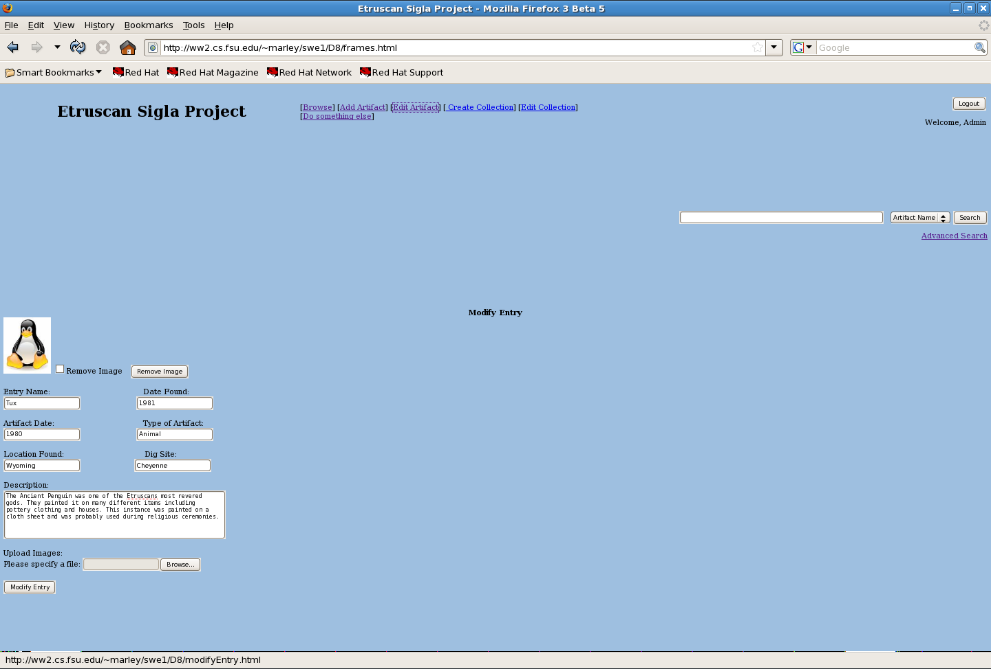

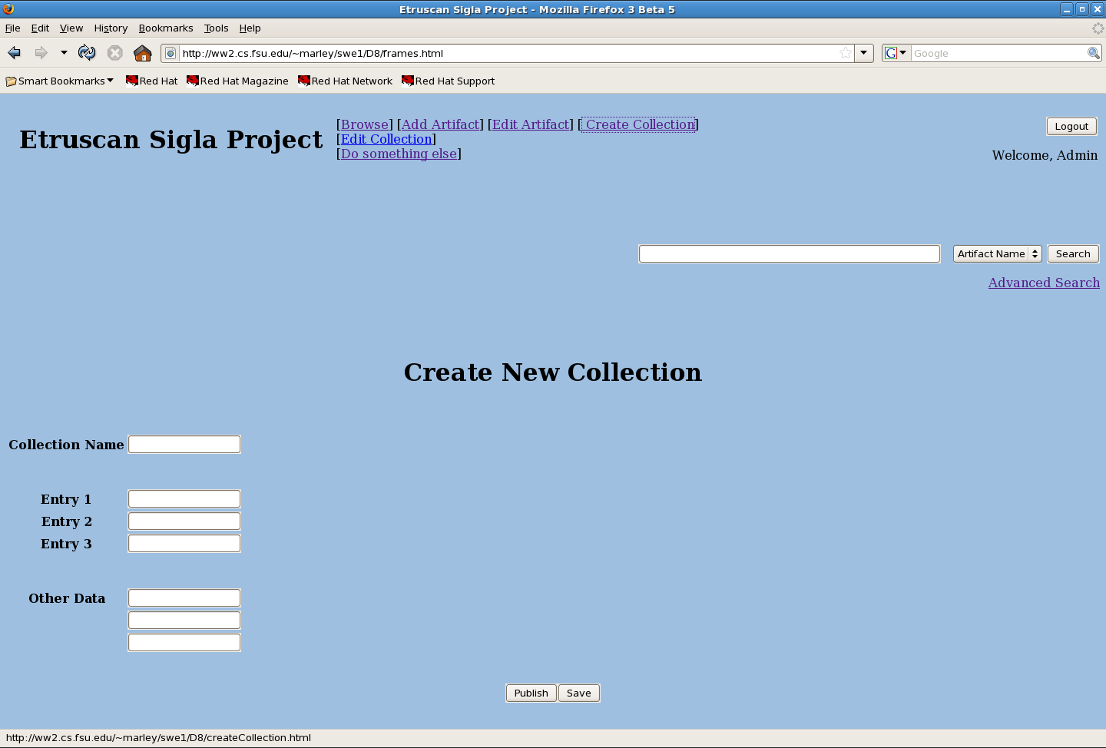

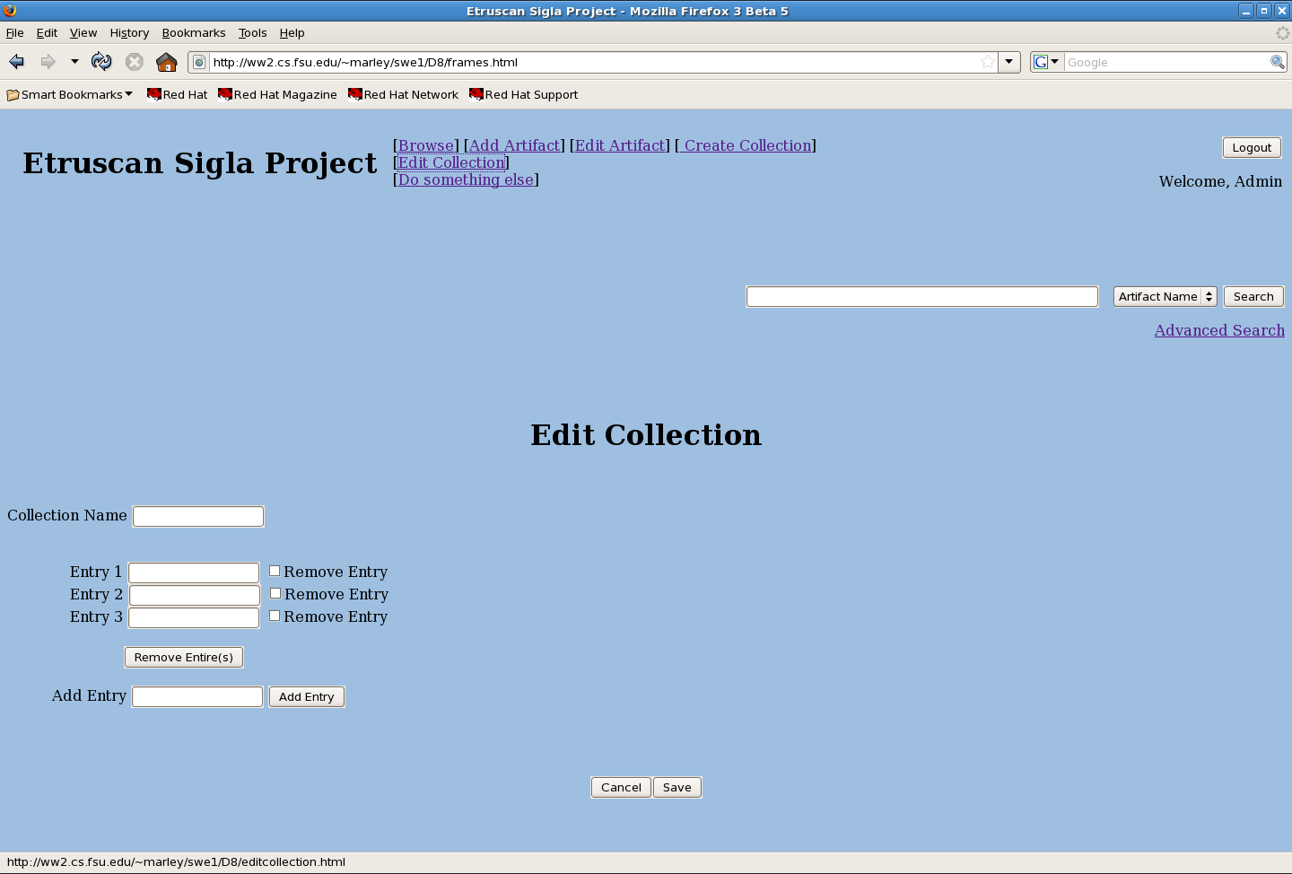

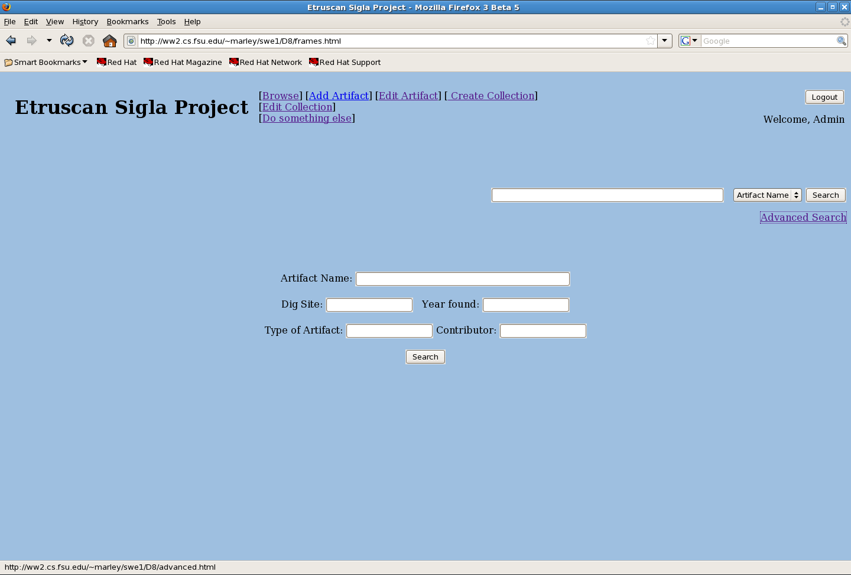

Appendix D: Scenarios Analysis Table
Scenario Analysis Tables

Use Case Name | Login
Use Case ID | 1

Normal Scenario
Step  # | Step Text | Data  Stored | Screens  Needed | Reports  Needed
1 | User enters name and password. |  | User Login Screen
2 | User selects the “Login” button. |  | User Login Screen
3 | System validates user information.
4 | Upon success, the user is granted access to unpublished files and appropriate privileges.

Use Case Name | Search
Use Case ID | 2

Normal Scenario
Step  # | Step Text | Data  Stored | Screens  Needed | Reports  Needed
1 | User enters text in the form corresponding to the field they want to search on. That is, the word(s) are what they’re searching for on the corresponding field. |  | Search Screen
2 | The user selects the field they want to search on from a selection given to them. They may search all fields for matches or a specific field. |  | Search Screen
3 | User selects the “Search” button. |  | Search Screen
4 | System queries the database for any entries that match or are similar to the search criteria
5 | System generates a web page of search results. |  | Search Results

Use Case Name | Retrieve Citation
Use Case ID | 3

Normal Scenario
Step  # | Step Text | Data  Stored | Screens  Needed | Reports  Needed
1 | User searches for artifact(s). |  | Search Screen
2 | User selects an artifact web page from the search results. |  | Search Results
3 | User views web page. |  | View Entry
4 | User selects the “Generate Citation” button. |  | Retrieve Citation
5 | System gathers relevant artifact information and provides a formatted citation. |  | Retrieve Citation

Use Case Name | Upload Additional Data
Use Case ID | 4

Normal Scenario
Step  # |  | Step Text | Data  Stored | Screens  Needed | Reports  Needed
1 | User logs into the system |  |  | Log In screen  (User name, Password)
2 | User selects option to upload additional data to an entry |  |  | Option Screen  (specifies how the user can interact with the system)
3 | User selects on which entry to upload additional data |  |  | Entry Selection Screen
4 | User adds new data to the entry |  |  | Entry Modification Screen
5 | User revises newly added data |  |  | Entry Modification Screen
6 | User saves additional data to entry |  | New data for specified entry | Entry Modification Screen, Entry Modification report screen (successful, failure)
7 | User signs out of the system |  |  | Log Out Screen

Use Case Name | Create Entry
Use Case ID | 5

Normal Scenario
Step  # |  | Step Text | Data  Stored | Screens  Needed | Reports  Needed
1 | User logs into the system |  |  | Log In screen  (User name, Password)
2 | User selects option to create new entry |  |  | Option Screen  (shows options on how the user can interact with the system)
3 | User adds all data corresponding to the new entry |  |  | New Entry Screen
4 | User revises new entry |  |  | New Entry Screen
5 | User saves new entry |  | New entry with specified data | New Entry Screen, New entry added report screen (successful, failure)
6 | User logs out of the system |  |  | Log Out Screen

Use Case Name | Publish Entry
Use Case ID | 6

Normal Scenario
Step  # |  | Step Text | Data  Stored | Screens  Needed | Reports  Needed
1 | User logs into the system |  |  | Log In screen  (User name, Password)
2 | User selects option to publish completed entry |  |  | Option Screen  (shows options on how the user can interact with the system)
3 | User revises entry |  |  | Entry Modification Screen
4 | User publishes entry |  | Newly Published Entry | Publish Entry Screen, Publish Entry Result Screen (successful, failure)
5 | User signs out of the system |  |  | Log Out Screen

Use Case Name | Modify Collection
Use Case ID | 7

Normal Scenario
Step  # |  | Step Text | Data  Stored | Screens  Needed | Reports  Needed
1 | User logs into the system |  |  | Log In screen  (User name, Password)
2 | User selects option to modify collection |  |  | Option Screen  (shows options on how the user can interact with the system)
3 | User modifies collection |  |  | Collection Modification Screen
4 | User revises modifications to the collection |  |  | Collection Modification Screen,
5 | User saves modifications to the collection |  | Newly update collection | Collection Modification result screen (successful, failure)
6 | User logs out of the system |  |  | Log Out Screen

Use Case Name | Modify Unpublished Entry
Use Case ID | 8

Normal Scenario
Step  # | Step Text | Data  Stored | Screens  Needed | Reports  Needed
1 | Contributor logs in to the System. | Log in info | Log in
2 | Contributor selects which of his entries to modify.
3 | Contributor changes text, photos or drawings for the entry |  | Modify Artifact
4 | Contributor saves his changes. | Changes to an entry
5 | Changes are written to the database
6 | Contributor logs out of the system

Use Case Name | Modify Published Entry
Use Case ID | 9

Normal Scenario
Step  # | Step Text | Data  Stored | Screens  Needed | Reports  Needed
1 | System Administrator logs in to the System. | Log in info | Log in
2 | System Administrator finds the entry with an error
3 | System Administrator fixes the error. |  | Modify Artifact
4 | System Administrator saves the changes. | Changes to an entry
5 | Changes are written to the database
6 | System Administrator logs out of the system

Use Case Name | Manage Contributor Accounts
Use Case ID | 10

Normal Scenario
Step  # | Step Text | Data  Stored | Screens  Needed | Reports  Needed
1 | System Administrator logs in to the system. | Log in info | Log in
2 | System Administrator looks up the account request. | Contributor info
3 | System Administrator evaluates the requester. |  | Manage Contributors
4 | System Administrator decides if the request will be granted.
5 | If the request is granted the account is created, otherwise nothing happens.
6 | System Administrator notifies the requester of the decision.
7 | System Administrator logs out of the system.

Use Case Name | Browse by Tree
Use Case ID | 11

Normal Scenario
Step  # | Step Text | Data  Stored | Screens  Needed | Reports  Needed
1 | User clicks on a link to go to another page. |  | View Artifact
2 | Step 1 is repeated until the User finds an entry they wish to  view.
3 | Steps 1 and 2 are repeated until the User finds an entry they wish to view. |  | Modify Artifact
4 | The User leaves the website.

Appendix E: Screens and Reports List

Screen/Report ID | Type | Screen/Report Name | Use Cases That Use this Screen/Report
SCR001 | I/O | View Artifacts | Search, View Published Entries, Retrieve Citation
SCR002 | I | Create Artifact | Create Entry, Login
SCR003 | I | Modify Artifact | Modify Unpublished Entry, Login
SCR004 | I | Manage Collection | Create Collection, Modify Collection
SCR005 | I | Publish Artifact | Publish Entry, Login
SCR006 | I | Upload Picture | Upload Additional Data, Login
SCR007 | I | Manage Contributors | Manage Contributor Accounts , Login

