−

Geriatric Medical Application Suite on a Sweet Phone

INTRODUCTION
Frank Sposaro and Gary Tyson
Older adults typically suffer from common, age related illnesses such as dementia, osteoporosis, and depression. These diseases can be detrimental, consuming both time and financial resources. However, the recent advancement of communication devices offers new capabilities to manage patient care. A new generation of programmable smartphones enables computer developers and geriatricians to combine efforts to create phone applications geared towards the medical needs of older adults; this field is called Gerontechnology. The resulting products will be cheaper and allow the user to live more independently than current implemented systems. Our research focuses on developing several programs, or apps, for the Android platform that address issues older adults may face such as falling, wandering, depression, visual impairment, and memory failure. These apps can learn specific patterns and be customized for the individual user. If they detect an emergency (i.e. user wanders outside of the house, falls, or becomes depressed), then the phone can automatically call for help.
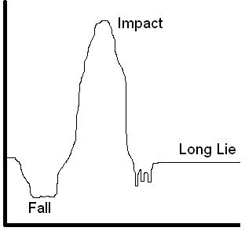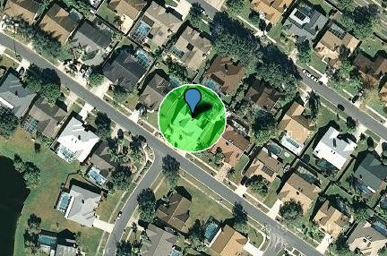
Fig. 1. The left image is an example of the total force applied to a tri-axis accelerometer during the course of a fall. The upper and lower thresholds can be adjusted based on the height, weight, and activity level of the user. The image to the right is a Google Map image depicting a variable radius in which a person with dementia should reside.

Materials and Methods
Our prototyped suite runs on any Android enabled smartphone. Different apps require certain hardware capabilities; however, required hardware is common in most smartphones.
Our first app, iFall, uses accelerometer data to detect a person falling and contacts support services without interaction from the patient (figure 1 - left). This is achieved by matching accelerometer data to a common fall pattern. Another app, iWander, uses GPS location sensing to monitor the movements of a user discreetly (figure 1 - right). This can be used to monitor dementia patients and alert support personnel when user is outside of an acceptable range.
Additional applications include monitoring communication tendencies and question prompting to detect depression, adjusting the phone’s default font and color schemes to be elderly friendly and basic appointment/pill reminders.
In the event of an emergency, the phone can automatically call several contacts using Google Voice technology. One Google Voice number can be dialed and Google can then ring multiple, pre-programmed numbers at once (figure 2). Those who answer will be connected to the user. The user’s phone can also enable speakerphone and adjust volume automatically in case the phone falls beyond the user’s reach.
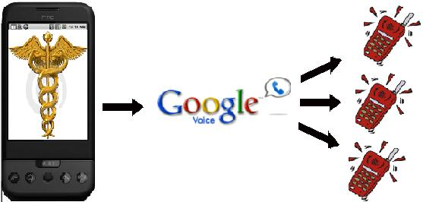
Fig 2. User’s phone can make one call to Google Voice when emergency occurs. Google Voice can then ring several cell phones simultaneously. Those who answer will be automatically connected.

Results
The Android platform with these specialized support applications allows users to live more independently, while offering care givers the ability to provide immediate intervention even when they are not present. An individual package can be tailored to a specific user along with each app. Users can select from among the set of monitoring facilities those that match their requirements. Each app is modular and can be installed on a case by case basis.
Our package also changes the default behavior of the Android operating system. We eliminate effects and features that are not well suited towards older adults. This is to make the phone easier to use and offer a more pleasant interaction with the device. Increased interactions allow for additional data mining and heighten the accuracy of our applications.
References
- Sposaro F. and Tyson G., "iFall: An android application for fall monitoring and response," in Conf Proc IEEE Eng Med Biol Soc, 2009;1:6119-22.
- Center for Technology and Aging, "Technologies for Remote Patient Monitoring in Older Adults," Position Paper, Discussion Draft, December 2009. techandaging.org.
- Shimizu, K.; Kawamura, K.; Yamamoto, K., "Location system for dementia wandering," Engineering in Medicine and Biology Society, 2000. Proceedings of the 22nd Annual International Conference of the IEEE , vol.2, no., pp.1556-1559 vol.2, 2000

  Manuscript received January 29, 2010 F. Sposaro is with Florida State University, Tallahassee, Florida 32313 United States (phone: 813.404.3972; fax: 850.644.0058; sposaro@cs.fsu.edu). G. Tyson is with Florida State University, Tallahassee, Florida 32313 United States (Tyson@cs.fsu.edu)

